See you all at the 5th anniversary Summer Party
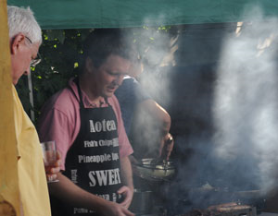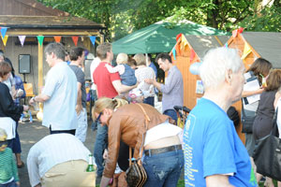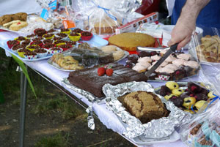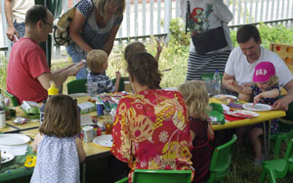
Saturday June 14th
http://www.southfieldparktriangle.org/index.htm

SPTRA 5th anniversary AGM
Rugby Road Scout Hut
09.45 – 10.45

Saturday May 3rd 2014

SPTRA Activities – 5 years of making a difference
Social and fun activities  - Quiz nights  - Festive events  - Book group  - SPTRA General Meetings  - Regular SNT updates  - Summer Party & special Children`s  events and secure area  News and Updates  - Regular updates – to 300 email addresses  - SPTRA website – at your fingertips  - Security notifications and alerts  - Police meetings  - Meeting/ dialogue with MP`s  - Meeting/dialogue with LBE  Attendance @  - Ward Forums  - Ward Surgery  - NHW Meetings as SPTRA and NHW Reps | Lobby  - Thames Tunnel  - Public Meetings & surgeries  - Contact with project team/LBE  - TT forum group  - Alley Gates  - Continuing reminders keeping you safe  - Trees  - New ones/roots/trimming and cutting  - Southfield Park  - 2 successful lighting projects  - Exercise equipment  - Project park improvements  - Planning issues  - Regular involvement and campaigns  - Security  - Specific improvements – alleys  - Police liaison  - SPTRA network neighbourhood watches  - CPZ consultation  - We won 2nd time of trying  - Southfield 20mph scheme

Agenda
- Welcome
- Accounts of SPTRA – 2013 to 2014
- Thank you’s over our 5 years
- Resignation / Election of the committee
- massive request for volunteers
- Keeping you posted - the SPTRA updates
    - Lighting in the park
    - Exercise in the park
    - Parking zone “R” consultation
    - Thames Tunnel
    - Speed limits
    - Other consultations
    - Gates
- Meeting closed

