See you at the Summer Party
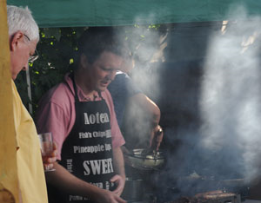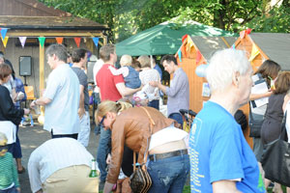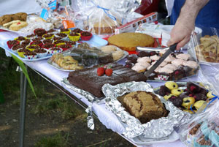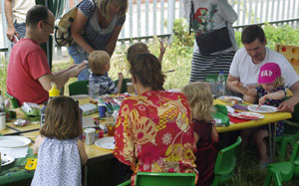
Saturday June 25th 3.00pm
http://www.southfieldparktriangle.org/index.htm

SPTRA 7th AGM
Rugby Road Scout Hut
09.45 – 10.30

Saturday May 7th 2016

SPTRA Summer Party
Saturday June 25th 3.00pm onwards

SPTRA Activities – making a difference
Social and fun activities and updates  - Quiz nights & Festive events  - SPTRA General Meetings  - Breakfast and evening meetings + wine  - Summer Party + special Children`s events  News and Updates  - Regular updates – to 300 email addresses  - SPTRA website  - Security notifications and alerts  - Police meetings and Regular SNT updates  - Telling you about scams that risk your security  - Dialogue with MP`s & Meetings with LBE  Attendance @  - Ward Forums & Ward Surgery  - Police Ward Panel  - Southfield Neighbourhood Watch  - Ealing Council Meetings  - Meetings with MP’s | SPTRA engagement  - Thames Water – smell / noise  - Public Meetings 120 people  - LBE & LBHF regulatory teams  - Involvement with MPs  - Expert medical opinion  - Pushing the Council!  - New trees/trimming and cutting  - The park - 2 street-lighting projects  - The Park – New Exercise equipment  - The Park – SPTRA Masterclass  - CPZ Consultation & 20mph scheme  - 20 more parking spaces for SPTRA  - Freshways Dairy  - Project Scout Hut

Agenda

- Welcome
- Accounts of SPTRA – 2015 to 2016
- Election of the committee
- Review of the year – we’re keeping you posted
    - More SPTRA Parking spaces – victory over council!
    - Project Scout Hut
    - Thames Water – good position
    - Freshways Dairy - fighting
    - Summer Party and next meeting
- Meeting closes 10.30

