2009-2019 SPTRA 2009-2019
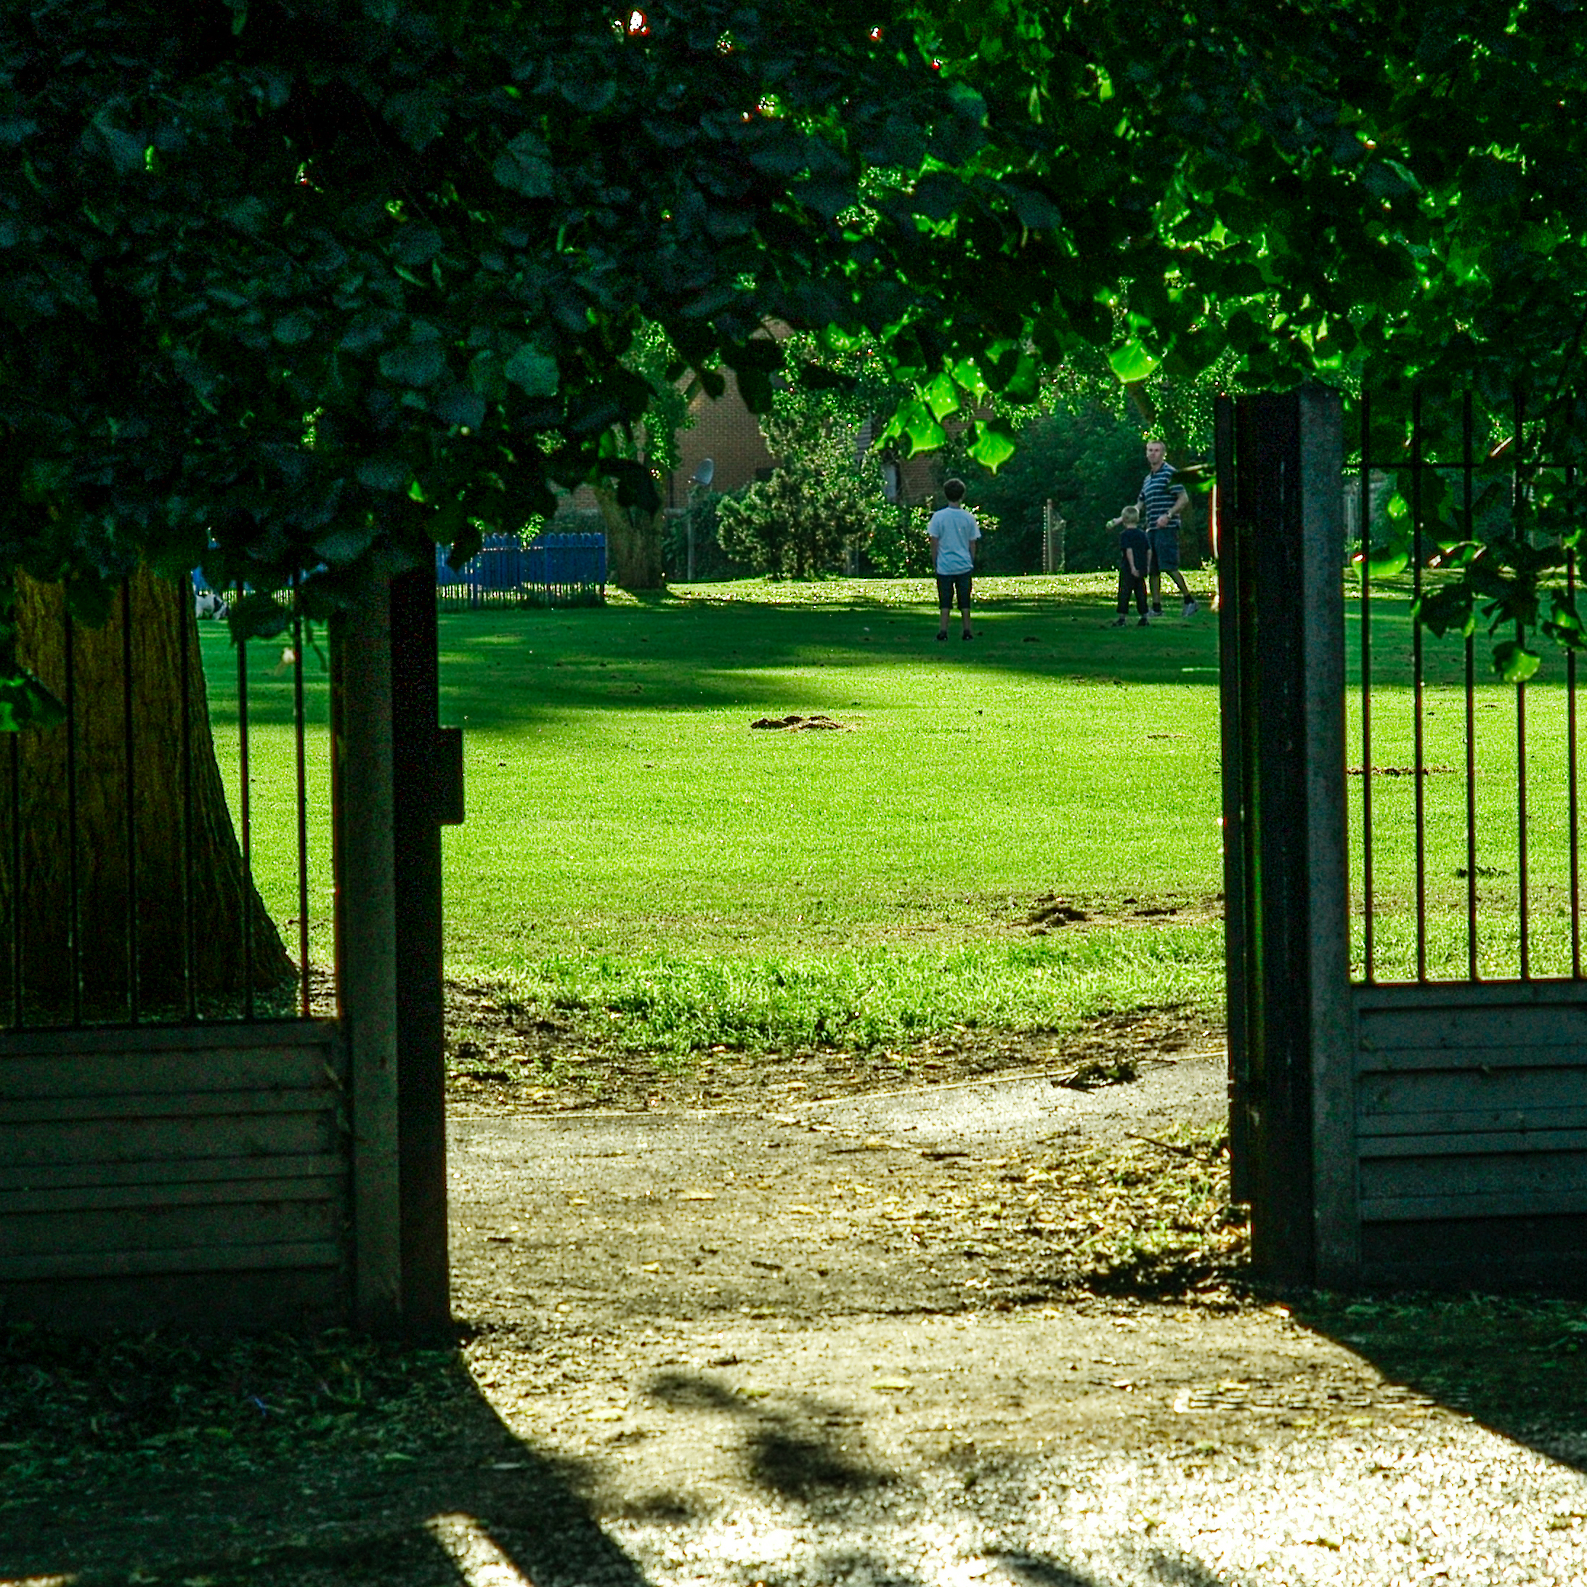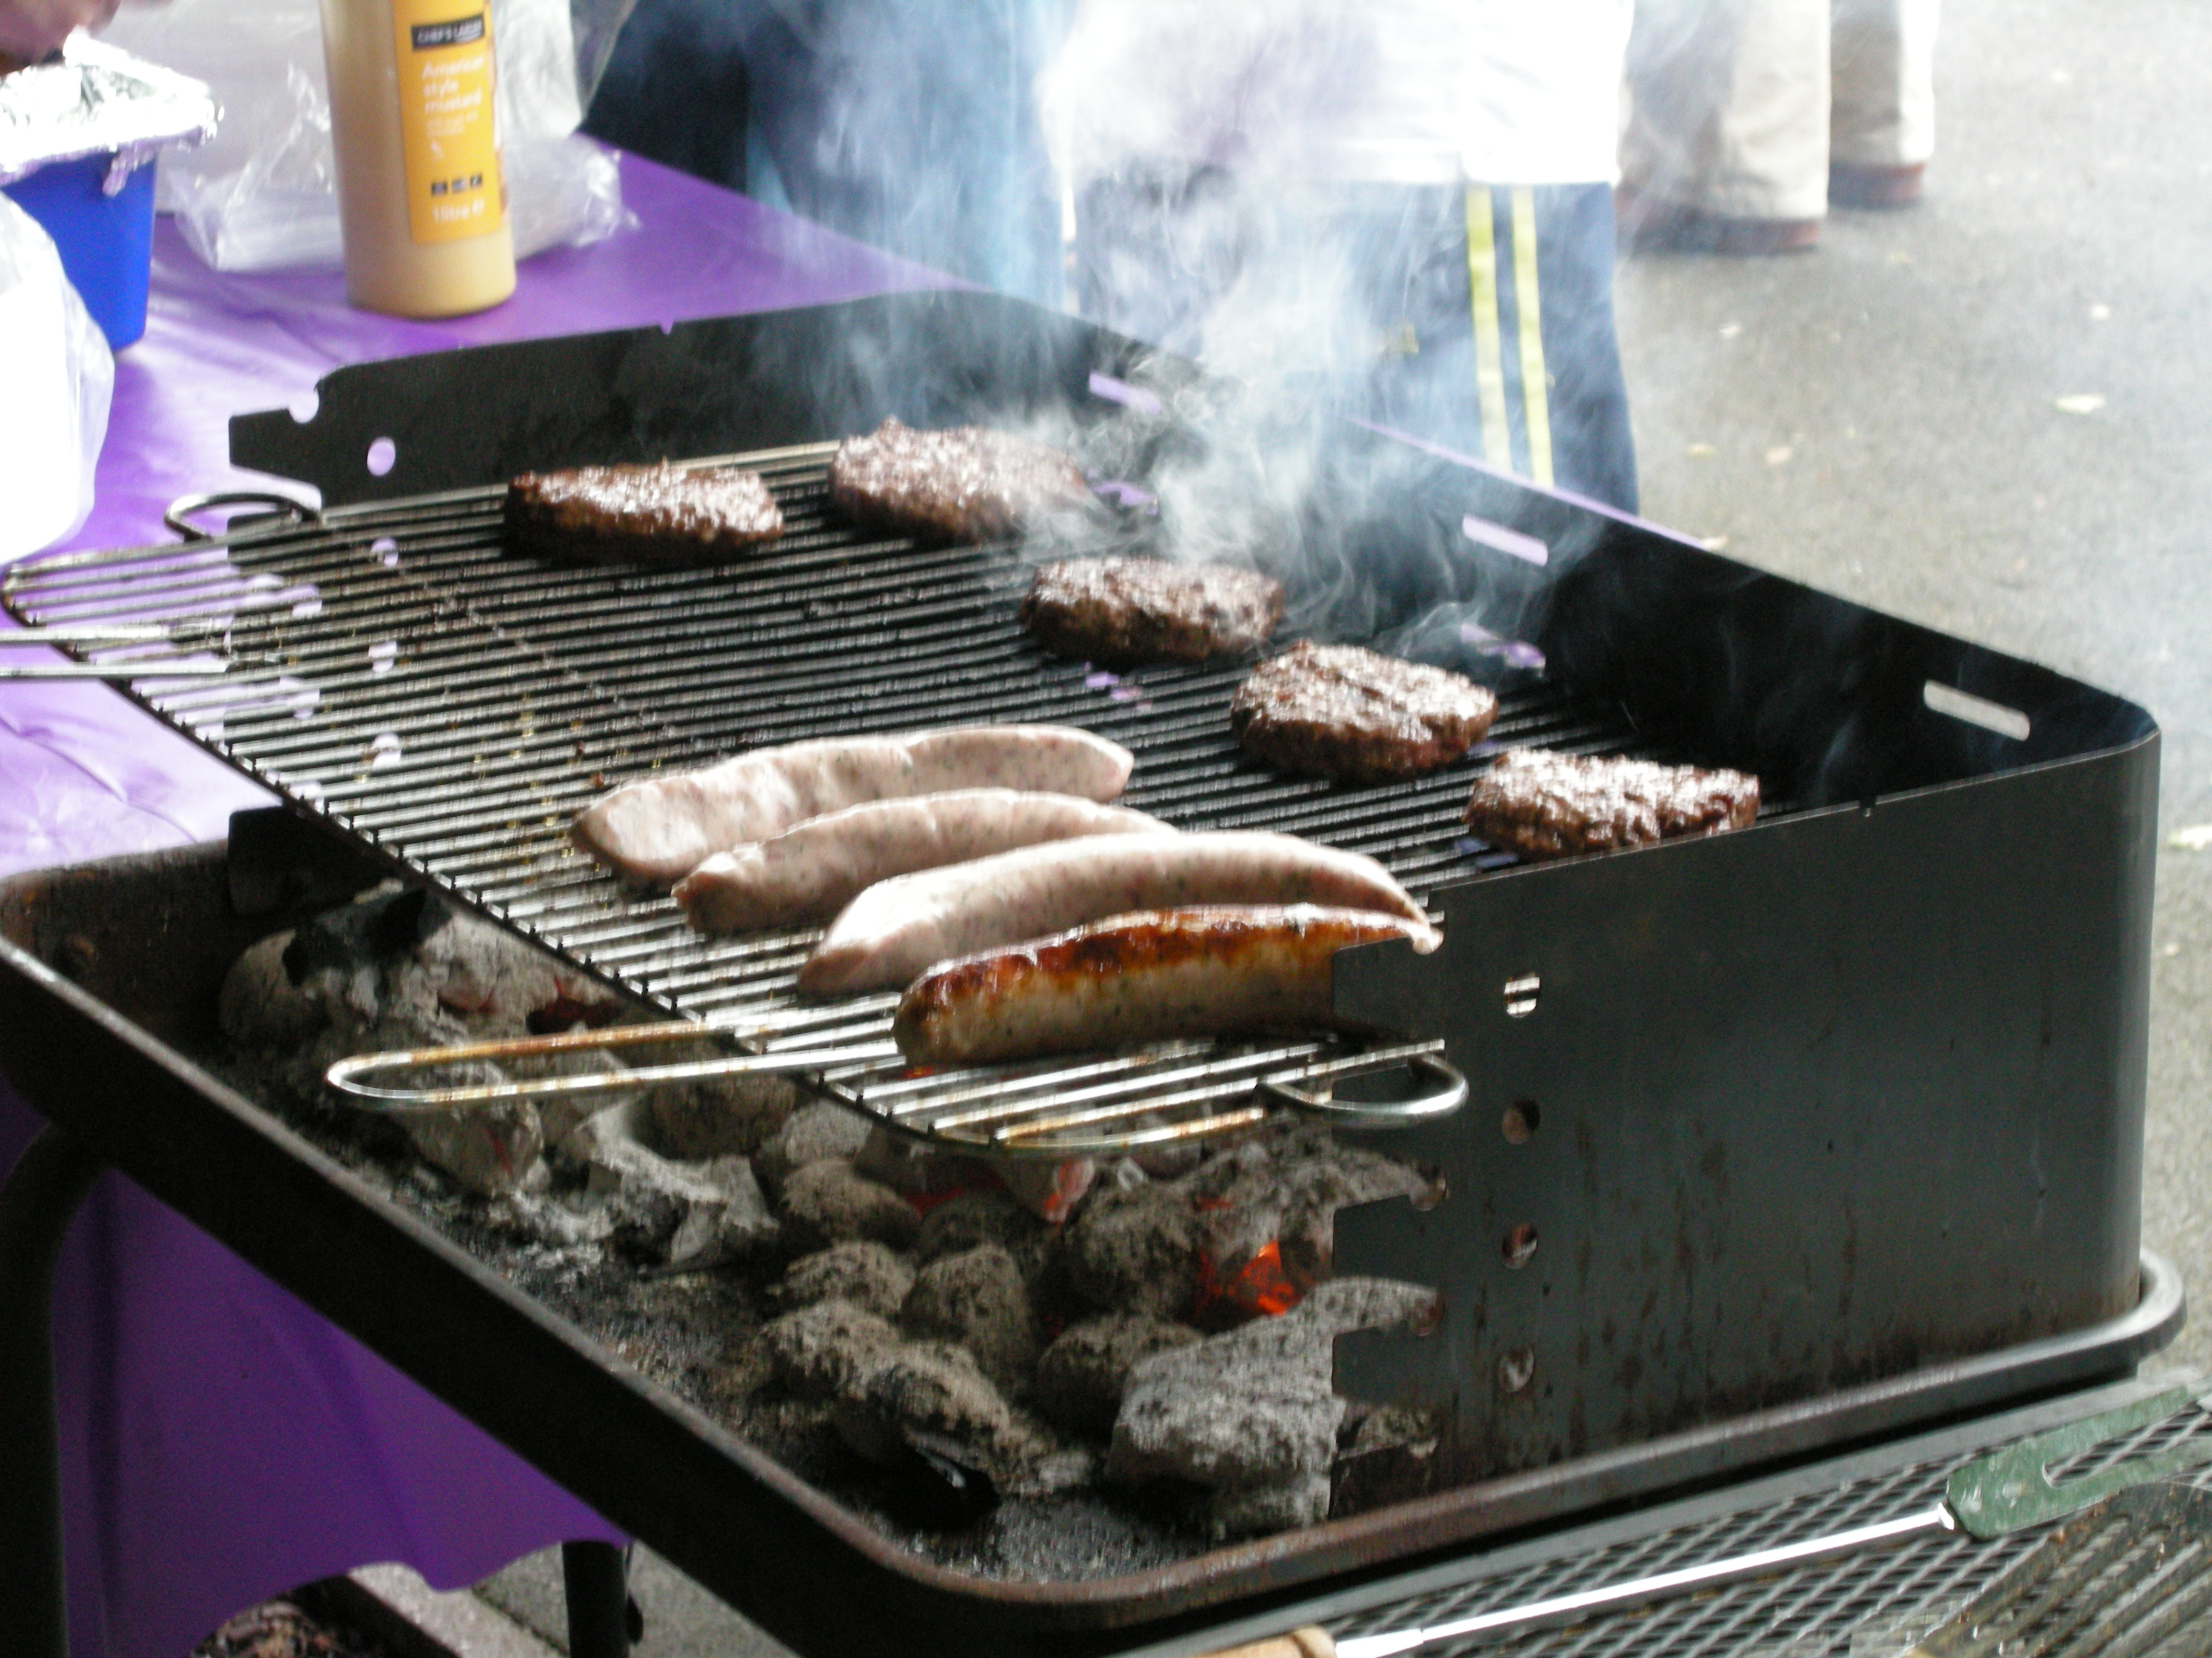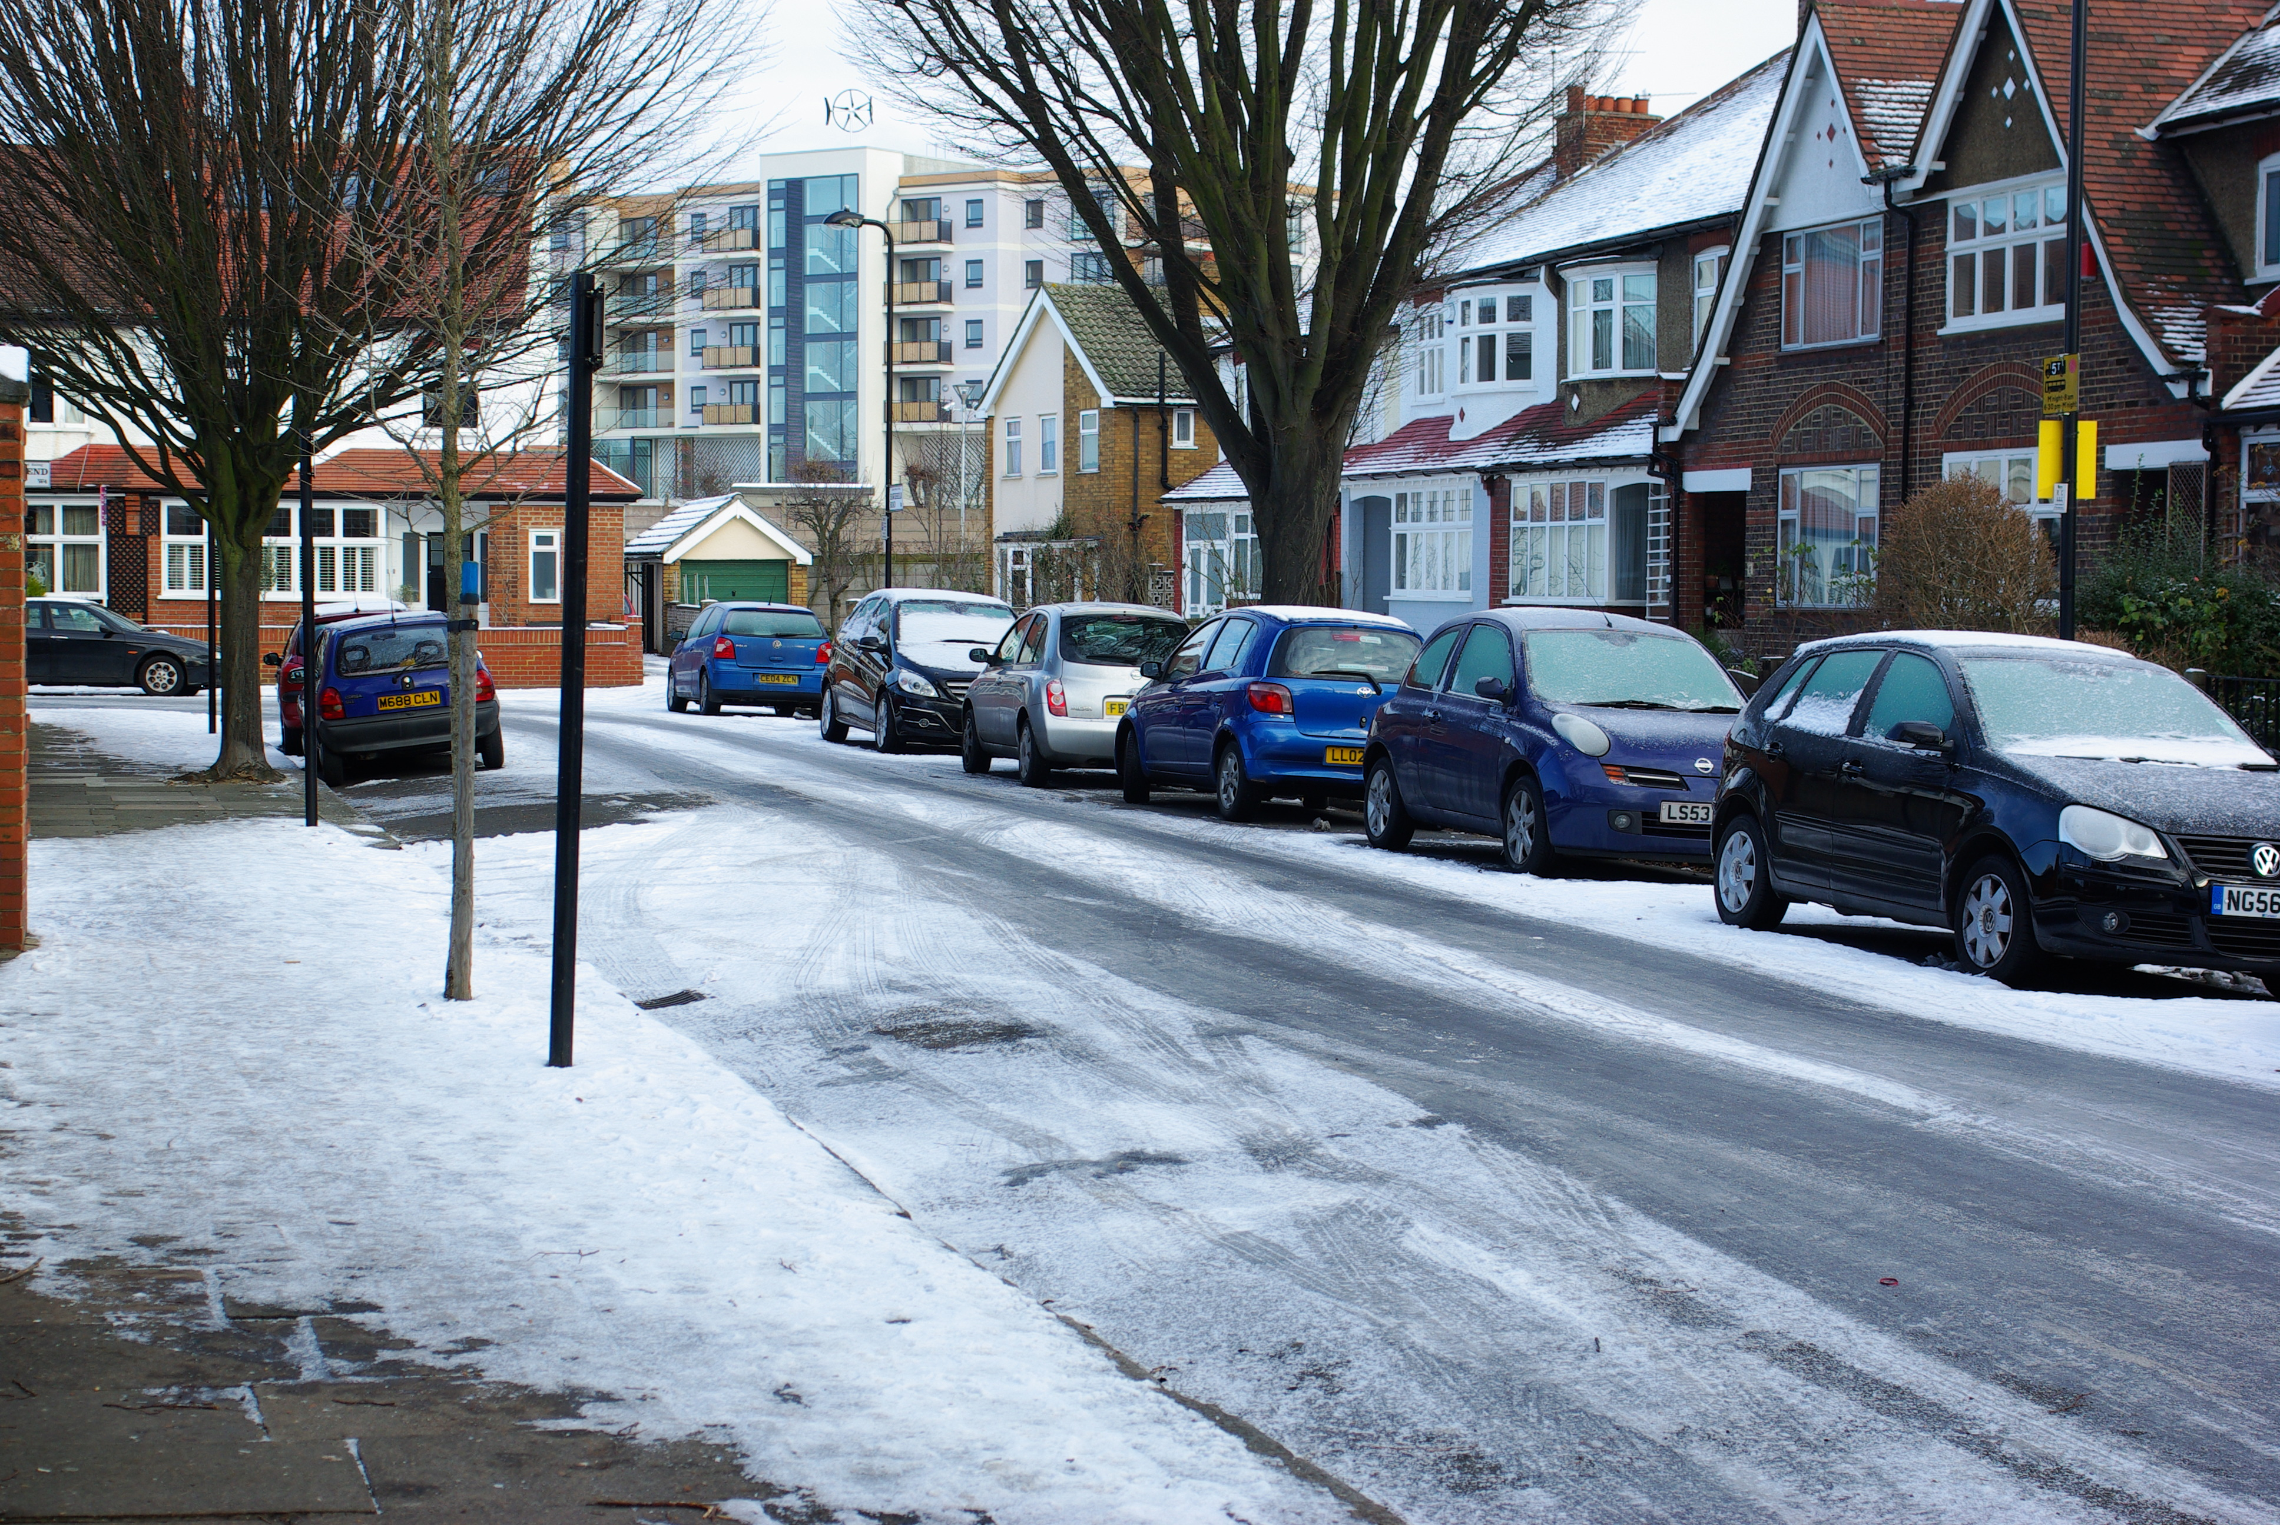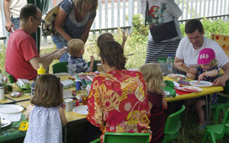
2009-2019 SPTRA 2009-2019
http://www.southfieldparktriangle.org/index.htm

2009-2019 SPTRA 2009-2019

SPTRA 8th AGM
Rugby Road Scout Hut
09.45 – 10.30
Saturday May 12th 2018

2009-2019 SPTRA 2009-2019

SPTRA Activities – making a difference
Social and fun activities and updates  - Quiz nights & Festive events  - SPTRA General Meetings  - Breakfast and evening meetings + wine  - Summer Party + special Children`s events  - Park SPTRA Masterclass  News and Updates  - Reaching out 300 emails  - SPTRA website  - Security notifications and scams alerts  - CCTV  - Police meetings and Regular SNT updates  Attendance @  - Ward Forums & Ward Surgery  - Police Ward Panel  - Southfield Neighbourhood Watch  - Ealing Council Meetings  - Meetings with MP’s | Engagement  - Thames Water – smell / noise  - Public Meetings  - LBE & LBHF teams + MP’s  - Expert medical opinion  - Victory  - Pushing the Council!  - New trees/trimming and cutting  - The park  - 2 street-lighting projects  - New Exercise equipment  - CPZ Consultation & 20mph scheme  - 20 more parking spaces  - Freshways Dairy  - Southfield Rd safety  - The Park – New expansion 2018  - Improving our Scout Hut  - Children 1st 2nd and last!

SPTRA You’re making the difference

Agenda
- Welcome
- Accounts of SPTRA – 2017 to 2018
- Election of the committee
- Review and Preview – keeping you posted
    - Thames Water – Storm Tanks
    - Project Scout Hut
    - CCTV
    - Who do we call……
    - Freshways Dairy – still fighting
    - Summer Party - anniversary
- Meeting closes 10.30

