See you all at the Summer Party
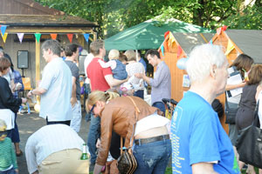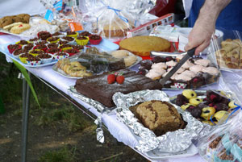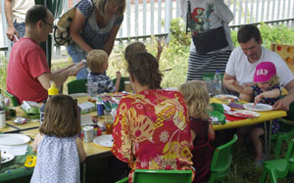
Saturday June 25th
http://www.southfieldparktriangle.org/index.htm

SPTRA 3rd AGM
Rugby Road Scout Hut
09.45 – 10.45

Saturday May 5th 2012

SPTRA Activities for all our neighbours
Social  - Quiz nights usually x2  - New Year events  - Book group  - Summer Party with special Children`s  events and secure area  News and Updates  - Regular emails and updates  - Maintenance of SPTRA website  - Security notifications  - Police meetings  - Meeting/ dialogue with MP`s  - Meeting/dialogue with LBE  Attendance  - Ward Forums  - Ward Surgery  - NHW Meetings as SPTRA and NHW Reps | Lobby  - Thames Tunnel  - Public Meeting Drop in sessions  - TT forum group  - Alley Gates  - Continued attention  - Trees  - New ones  - Roots under houses  - Over cutting them  - Southfield Park  - Public debate leading to successful lighting project  - Planning  - Regular involvement  - Security  - Specific improvements – alleys  - Police liaison  Controlled Parking zone consultation

Agenda
- Welcome
- SPTRA Constitution
- Accounts of SPTRA – 2011 to 2012
- Thank you to those people who have contributed to what we do
- Resignation of the committee
  - Resignations received wef effect this AGM
- Election of the committee - request for volunteers
- Meeting closed

