See you all at the Summer Party
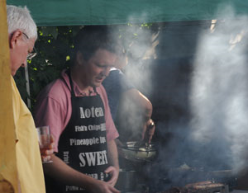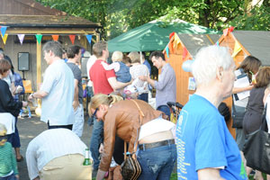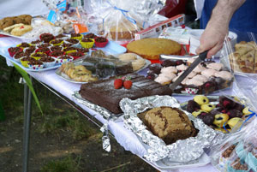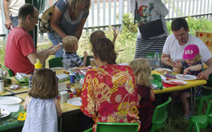
Saturday June 22nd
http://www.southfieldparktriangle.org/index.htm

SPTRA 4th AGM
Rugby Road Scout Hut
09.45 – 10.45

Saturday May 4th 2013

SPTRA Activities for all our neighbours
Social  - Quiz nights  - Festive events  - Book group  - Summer Party & special Children`s  events and secure area  News and Updates  - Regular emails and updates  - Maintenance of SPTRA website  - Security notifications  - Police meetings  - Meeting/ dialogue with MP`s  - Meeting/dialogue with LBE  Attendance @  - Ward Forums  - Ward Surgery  - NHW Meetings as SPTRA and NHW Reps | Lobby  - Thames Tunnel  - Public Meetings  - Contact with project team/LBE  - TT forum group  - Alley Gates  - Continued attention  - Trees  - New ones/nasty roots  - Southfield Park  - Successful lighting project  - Exercise equipment  - Planning issues  - Regular involvement  - Security  - Specific improvements – alleys  - Police liaison  7. CPZ consultation

Agenda
- Welcome
- Accounts of SPTRA – 2012 to 2013
- Thank you’s to those people who have contributed
- Resignation / Election of the committee
- Request for volunteers
- Keeping you posted - the SPTRA updates
    - Lighting in the park
    - Exercise in the park
    - Parking zone “R” consultation
    - Thames Tunnel
    - Speed limits
    - Other consultations
    - Gates
- Meeting closed

